**Project Design Phase-II**

**Data Flow Diagram & User Stories**

| Date | 26-05-2025 |
| --- | --- |
| Team ID | LTVIP2025TMID59352 |
| Project Name | ShopSmart:Your digital grocery store experience |
| Maximum Marks | 4 Marks |

**Data Flow Diagrams:**

A **Data Flow Diagram (DFD)** illustrates how data moves within the Resolve Now platform. It captures how user interact with the system, how information flows between different components, and where the data is stored.

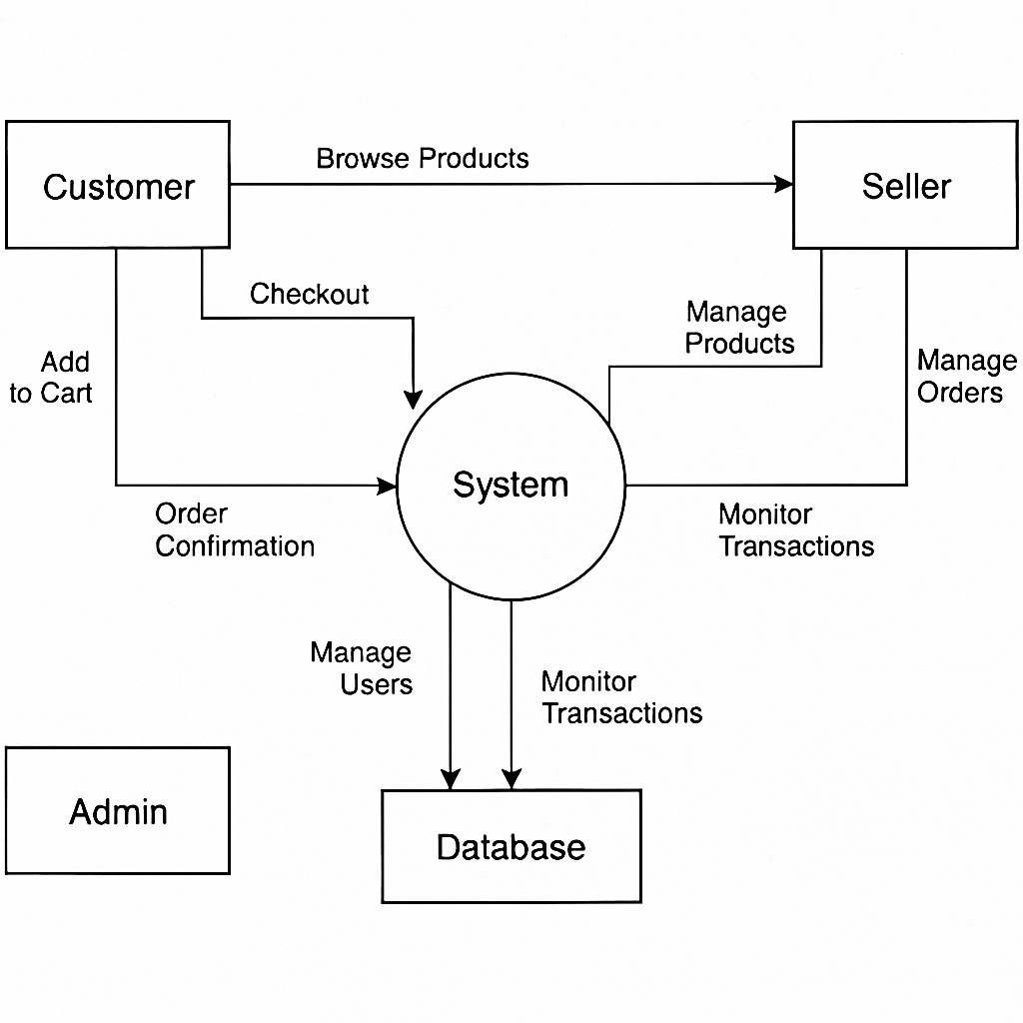

**User Story Table – Freelance Finder**

| **User Type** | **Functional Requirement (Epic)** | **User Story / Task** | **Acceptance Criteria** | **Priority** | **Release** |
| --- | --- | --- | --- | --- | --- |
| **Customer** | |  | | --- |  | Product Browsing | | --- | | As a customer, I can browse and filter grocery items. | Product list updates dynamically based on filters. | High | Sprint-1 |
| **Customer** | Cart & Checkout | | As a customer, I can add products to my cart and complete checkout.. | | --- | | Cart updates instantly and checkout shows confirmation. | High | Sprint-2 |
| **Seller** | Product Management | As a seller, I can manage my product listings and inventory. | Products show live on platform after update. | Medium | Sprint-2 |
| **Admin** | System Monitoring | As an admin, I can monitor order and payment activity. | Transaction logs and analytics dashboard update in real time. | High | Sprint-2 |
| **Admin** | System Monitoring | As an admin, I can monitor order and payment activity. | Transaction logs and analytics dashboard update in real time. | Medium | Sprint-4 |